AI Agentic Workflow Patterns

The first time most of us used a large language model, it felt almost magical.

- You typed a prompt.
- It responded.
- And that was it.

For quick answers, brainstorming ideas, or generating a paragraph of text, this one-shot interaction felt more than enough. Ask a question, get a response, move on. Simple. Efficient. Satisfying.
But the moment we started asking AI to do real work, the cracks began to show.

Try asking an AI to analyze market trends, cross-check sources, synthesize insights, and then turn all of that into clear, actionable recommendations. What you usually get back is something that sounds smart but feels incomplete. There’s no chance for the model to pause, gather more context, question its own assumptions, or improve its output based on what it just learned.

It’s not because the model isn’t powerful.
It’s because we’re asking it to think in a single breath.

This is where agentic workflows change everything.

Instead of treating AI as a one-time responder, agentic workflows turn it into a system that can plan, act, reflect, and iterate. They allow models to use tools…

The difference is similar to a rough sketch versus a finished painting. Both start with an idea, but only one improves through revision, feedback, and intent. When reliability, depth, and trust matter, iteration always wins.

In this article, we’ll explore the most important agentic workflow patterns, why they’ve become foundational in modern AI systems, and how they’re shaping the way real products are being built in 2026.

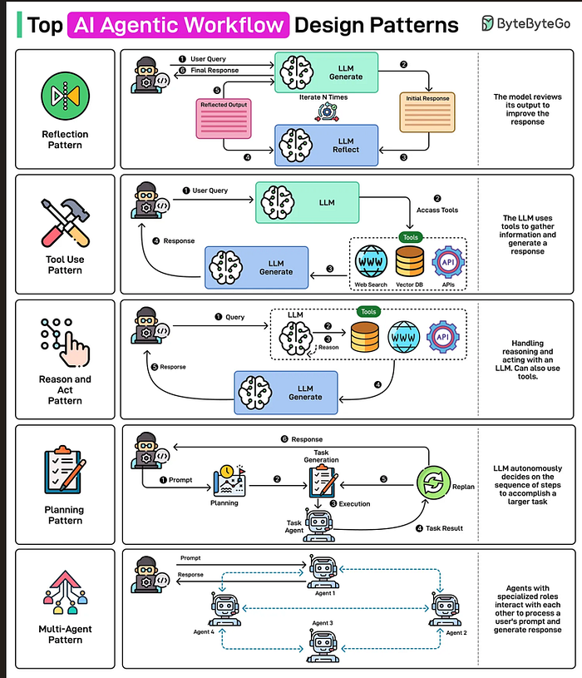

Understanding Agentic Workflows

An agentic workflow doesn’t simply wait for instructions and produce a response. It operates with a degree of independence deciding how to approach a task, which steps make sense next, and when to adjust its strategy based on what it learns along the way.

This might sound like a small distinction at first, but it represents a fundamental shift in how we design and think about AI systems.

To see the difference clearly, imagine asking a basic chatbot to help you write a research report. You give it a prompt, and it generates a complete draft in one go, based entirely on its existing knowledge and whatever assumptions it makes upfront. The result may look polished, but it’s static. There’s no room for exploration, validation, or correction once the response is generated.

An agentic system approaches the same task very differently.

It might begin by gathering up-to-date information from external sources. Then it could cluster those findings into themes, outline the structure of the report, and draft each section individually. Along the way, it may pause to evaluate whether a section is weak, unclear, or inconsistent, revise it, and only then move forward. Each step involves choices what tool to use, what information matters, and what needs refinement based on what the system uncovers in real time.

What truly makes these workflows agentic is the presence of iteration and feedback loops.
Instead of producing output in a single pass, the agent acts, observes the outcome, and uses that observation to guide the next action. This is much closer to how humans solve complex problems. We don’t usually start with a perfect plan. We experiment, notice what works or fails, and adjust as we go.

Agentic workflows bring this same adaptive, reflective process into AI systems allowing them to move beyond static responses and toward more thoughtful, reliable problem-solving.

The Five Essential Agentic Workflow Patterns

Now that we understand what makes a workflow truly agentic, let’s look at the patterns that show up again and again in real systems.

These aren’t abstract theories. They’re practical design approaches that teams use to move beyond “smart responses” and toward AI systems that can reason, adapt, and improve over time.
We’ll start with the most fundamental one.

Agentic Workflow Patterns(Quick links)

- Reflection Pattern — The Self-Improving Agent
- Tool Use Pattern — Extending Agents Beyond Language
- Reason and Act (ReAct) Pattern — Thinking While Doing
- Planning Pattern — Strategic Structure for Complex Tasks
- Multi-Agent Pattern — Collaboration Through Specialization

Reflection Pattern: The Self-Improving Agent

At its core, reflection is about giving an agent the ability to step back and evaluate its own work before treating anything as final.

It’s a simple idea, but it has an outsized impact on quality.

Instead of assuming the first output is good enough, a reflective agent reviews what it just produced, looks for weaknesses or mistakes, and then revises accordingly. This introduces an intentional refinement loop one that consistently catches errors, improves clarity, and strengthens the final result.
In practice, the reflection cycle usually looks like this:

First, the agent generates an initial output based on the task or prompt it receives.

Next, rather than immediately returning that output, the agent switches into a critique mindset. It examines its own work, asking questions like: Does this make sense? Is anything missing? Are there inconsistencies or weak explanations? The goal here isn’t perfection it’s awareness.

That critique then becomes the input for revision.

Using its own feedback, the agent produces an improved version that directly addresses the issues it
identified. In many implementations, this process doesn’t stop after one pass. The cycle may repeat several times, with each iteration incrementally improving the output.

What’s powerful about this pattern is how closely it mirrors human thinking. When we write, design, or analyze something important, we rarely get it right on the first attempt. We review, rethink, and refine.

Reflection brings that same discipline into AI workflows.

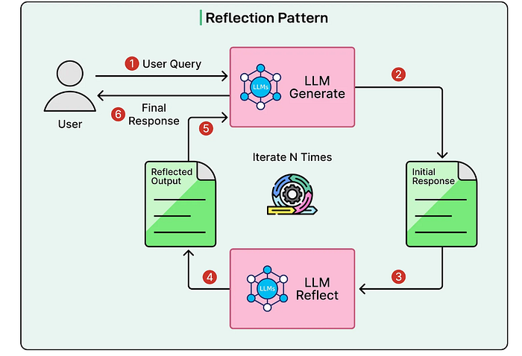

The real strength of the reflection pattern becomes obvious when the agent isn’t just “reviewing,” but reviewing with intent.

Reflection doesn’t have to be generic. In practice, it’s often far more effective when the agent is asked to critique its work from a specific angle focusing on one dimension of quality at a time.

For example, an agent might reflect purely on accuracy, checking whether the facts it presented are correct, up to date, and properly supported. This is especially valuable in research-heavy or analytical tasks where small inaccuracies can undermine trust.

In other cases, reflection is about clarity. The agent reviews its own explanation and asks whether someone unfamiliar with the topic would actually understand it. Jargon, assumptions, or poorly structured ideas often surface here and can be corrected before the output reaches a reader.
Creative tasks benefit in a different way. When writing stories, blog posts, or marketing copy, reflection can focus on tone and voice does this sound right for the intended audience? Is it too formal, too casual, too generic? A single reflection pass can dramatically improve how human the writing feels.

For code generation, reflection often takes on a more technical role. The agent can review its own code to look for obvious bugs, security risks, edge cases, or opportunities to improve performance and readability. While it won’t replace proper testing or human review, it frequently catches issues that a single-pass generation would miss.

That said, reflection isn’t something you apply everywhere.

This pattern shines when quality matters more than speed, and when the task has subjective elements that benefit from judgment and refinement. It’s far less useful for simple, factual questions where the answer is obvious, or in situations where speed is critical and “good enough” truly is enough.

Like most agentic patterns, reflection is powerful not because it’s complex, but because it’s used intentionally.

Tool Use Pattern: Extending the Agent Beyond Its Own Knowledge

The tool use pattern marks a major turning point in what AI agents can realistically do.

On its own, even the most advanced language model is fundamentally limited. It reasons based on patterns it learned during training and generates text from that internal knowledge. It doesn’t know what happened yesterday. It can’t reliably crunch large numbers. It can’t pull records from a database or interact with the outside world.

Tools are what break that boundary.

When we introduce tool use into an agentic workflow, we’re no longer asking the model to pretend it knows everything. Instead, we give it the ability to reach out — to fetch fresh information, run calculations, query systems, and act on real data when needed.

In this pattern, an agent is equipped with a collection of tools it can call dynamically. These might include web search for up-to-date information, APIs for services like weather or market data, code execution environments for running programs and performing precise calculations, database query tools for retrieving specific records, or file system access for reading and writing documents. In practice, this list grows quickly as systems become more specialized.

What makes this pattern truly agentic isn’t the tools themselves — it’s who decides to use them.

Unlike traditional software, where tool usage is hardcoded by developers, an agentic system decides when a tool is necessary and how to use it based on the task it’s trying to complete. If the agent realizes it lacks information, it can search. If a calculation feels risky to do in its head, it can run code. If a decision depends on external data, it can query a system.

This autonomy is what turns a language model from a static responder into an active problem solver.
Instead of forcing everything through text generation, tool-using agents learn to combine reasoning with action — bridging the gap between intelligence and execution.
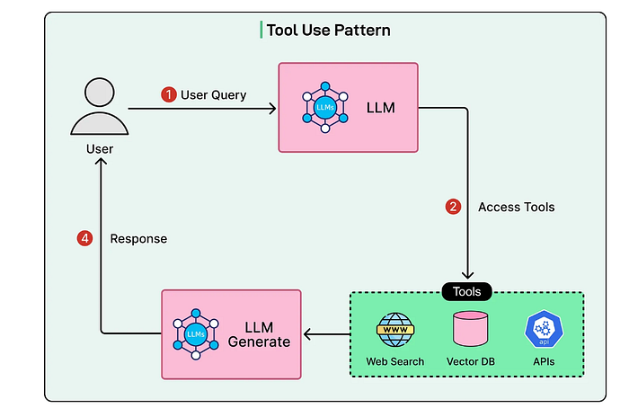
When an agent is given a task, its first step isn’t to generate an answer — it’s to figure out what it needs in order to succeed.

Sometimes the agent realizes that it simply doesn’t have enough information. In those cases, it knows to reach for a search or data-retrieval tool instead of guessing. If the task involves calculations or data manipulation, it may decide that running code or using a calculator is safer than reasoning it out in text. And when the task depends on interacting with an external system such as fetching prices, triggering a workflow, or updating a record the agent selects the appropriate API and works through that interface.

What makes this pattern especially powerful is that tool usage isn’t static or one-off. It’s dynamic and composable.

An agent can chain multiple tools calls together, using the output of one step to inform the next. A search result may lead to a database query, which then feeds into a calculation, which finally shapes the response presented to the user. Each action is chosen in context, based on what the agent learns as it goes.

Just as important, the agent isn’t locked into a predetermined script.

If a search returns weak or incomplete results, the agent can reformulate the query and try again. If an API call fails or returns an unexpected error, it can switch strategies retrying with different parameters or selecting an alternative tool altogether. This ability to adapt in real time is what separates tool-enabled agents from traditional automation.

Instead of brittle, linear workflows, you get systems that can recover, explore, and adjust making them far more resilient and capable in messy, real-world environments.

Reason and Act Pattern (ReAct)

The Reason and Act pattern often referred to as ReAct captures a more realistic way of solving problems.

Instead of forcing an agent to think through an entire plan upfront, or letting it take actions without reflection, ReAct blends the two. The agent alternates between reasoning about what to do next and actually doing it. This back-and-forth creates a problem-solving process that feels natural, flexible, and surprisingly human.

At a high level, ReAct works because it avoids extremes. Planning everything in advance assumes perfect information. Acting without thinking assumes mistakes don’t matter. Real-world problems rarely allow either. ReAct sits in the middle.

The cycle itself is straightforward.

First, the agent pauses to reason about the current situation. It considers what it already knows, what information is missing, what constraints exist, and which options are available. This reasoning step is explicit. The agent actively evaluates possible paths forward instead of jumping to a conclusion.

Based on that reasoning, the agent then takes an action. This could be calling a tool, fetching information, running a calculation, or making a concrete decision that moves the task forward.

Once the action is complete, the agent observes the outcome. It then enters another reasoning phase, reflecting on what it learned, whether the result was useful, and what the next step should be.

From there, the cycle repeats.

This loop continues until the agent decides it has achieved the goal — or recognizes that it can’t proceed further with the information or tools available.

What makes ReAct especially powerful is its adaptability. The agent isn’t locked into a rigid plan, nor is it reacting blindly. Each action is informed by reasoning, and each reasoning step is grounded in real feedback from the environment.

In practice, this pattern allows agents to navigate uncertainty far more effectively than linear workflows ever could.
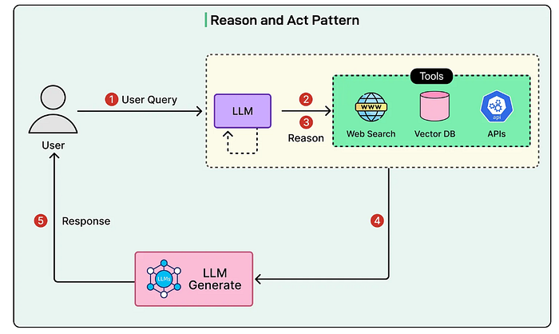
The explicit reasoning steps in a ReAct workflow aren’t just an implementation detail, they’re what make the pattern reliable.

To start with, reasoning helps the agent stay oriented around the goal. By repeatedly articulating what it’s trying to achieve and why a particular action makes sense, the agent is far less likely to wander into irrelevant directions or get stuck repeating unproductive behaviors. That small pause to think often prevents large mistakes later.

Reasoning also enables adaptation. When an action produces an unexpected or weak result, the agent doesn’t simply push forward out of momentum. The reasoning phase gives it space to ask why something didn’t work and to adjust its strategy accordingly. This is what allows ReAct-based systems to recover instead of fail silently.

There’s another benefit that often gets overlooked: transparency.

Because the reasoning steps are explicit, developers and users can see not only what the agent did, but the logic behind those decisions. This visibility is invaluable when you’re trying to debug behavior, build trust in automated systems, or understand why an agent arrived at a particular outcome.

The value of ReAct becomes even clearer when you compare it to the two extremes it replaces.

Pure planning assumes you can map out every step before taking action. That works in controlled, predictable environments but it quickly breaks down when information is incomplete, when discovery is part of the task, or when conditions change mid-way.

Pure execution sits on the opposite end of the spectrum. Acting without much forethought is fast, but it’s also brittle. Errors compound quickly, and there’s little opportunity to course-correct once the system goes off track.

ReAct finds a practical middle ground. It provides just enough structure through reasoning to stay focused, while preserving the flexibility of acting, learning, and adjusting in real time. In messy, real-world problems, that balance is often the difference between something that looks impressive in a demo and something that actually works.

Planning Pattern

The planning pattern takes a different approach from ReAct by emphasizing upfront strategic thinking before execution begins.

When using the planning pattern, the agent starts by analyzing the overall goal and understanding what success looks like. It then breaks down this goal into smaller, more manageable subtasks. This decomposition continues until the agent has identified concrete, actionable steps.

Crucially, the agent identifies dependencies between tasks, determining which steps must be completed before others can begin and which steps can potentially happen in parallel. The agent also considers what resources, tools, or information each step will require. Only after creating this structured plan does the agent begin execution.
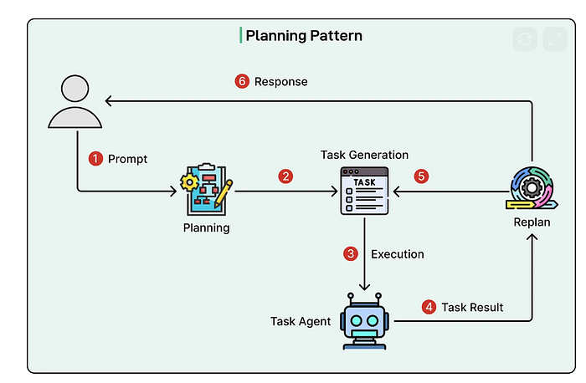
One of the planning pattern’s greatest strengths is adaptive planning.

This isn’t about creating a rigid, step-by-step script and blindly following it. Instead, the agent forms a structured plan while remaining open to revisiting and adjusting that plan as new information emerges. The plan provides direction but not blind commitment.

The planning pattern works best when a task naturally breaks into clear phases, where certain steps logically need to happen before others. It’s especially useful when there are real-world constraints involved deadlines, budgets, limited compute, or shared resources where coordination and sequencing matter.

This pattern also shines in situations where mistakes are expensive. If backtracking would waste time, money, or trust, it’s worth slowing down early and thinking things through. Complex projects with multiple parallel work streams research, analysis, execution, and review benefit enormously from having a high-level plan that keeps everything aligned.

That said, planning is not a universal solution.

For simple, linear tasks where each step naturally suggests the next, formal planning often adds unnecessary overhead. In those cases, the task itself already provides enough structure, and introducing a planning phase can feel like overengineering.

Planning also struggles in highly uncertain environments. When critical information is likely to surface only during execution and that information could fundamentally change the direction heavy upfront planning may end up being wasted effort. The agent might spend more time planning for scenarios that never materialize than actually making progress.

Like most agentic patterns, planning is powerful when applied with intent. Used thoughtfully, it creates clarity and alignment. Used indiscriminately, it can slow things down.

Multi-Agent Pattern: Building Systems That Think in Teams

The multi-agent pattern represents one of the most powerful and most nuanced ways to build AI systems.

Rather than asking a single agent to do everything, this approach distributes work across multiple specialized agents that collaborate toward a shared goal. Each agent is designed with a particular strength, perspective, or responsibility, and together they operate much like a well-structured human team.

At the heart of this pattern is a simple but important insight: specialization usually beats generalization.

When a single agent is expected to handle every aspect of a complex task, it quickly runs into trade-offs. It needs to reason deeply, stay creative, remain critical, manage tools, and coordinate steps all at once. Balancing those competing demands inside a single system often leads to shallow results in at least some areas.

Multi-agent systems sidestep this problem by dividing responsibilities.

One agent might focus on research and information gathering. Another might evaluate accuracy or risks. A third could handle synthesis, planning, or final presentation. Each agent can be optimized for its specific role, without having to compromise to serve every purpose at the same time.

This mirrors how effective teams work in the real world. We don’t expect one person to be equally good at strategy, execution, quality control, and communication. We assign roles and AI systems benefit from the same structure.

By allowing agents to collaborate instead of multitask endlessly, the multi-agent pattern enables deeper reasoning, better checks and balances, and more reliable outcomes especially as tasks grow in complexity.
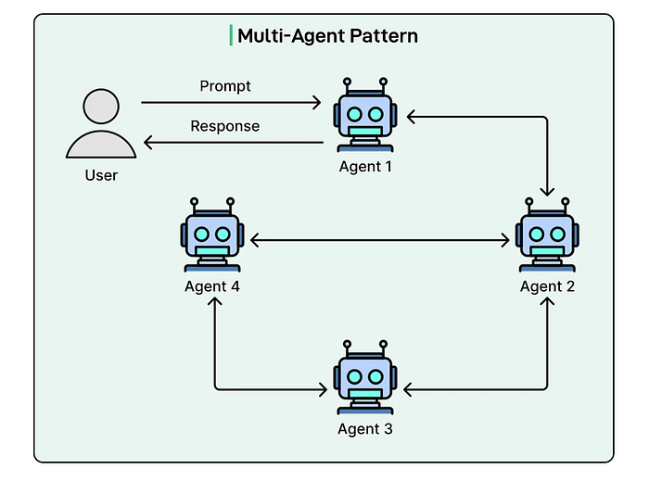
In practice, multi-agent systems tend to organize themselves around a few recurring roles.

You’ll often see specialist agents designed for specific domains or tasks. A research agent might excel at finding and synthesizing information. A coding agent may focus on writing, testing, and debugging code. A data analysis agent could be optimized for statistics, modeling, or visualization.

Each specialist is tuned for depth rather than breadth.
Alongside these, many systems introduce critic or review agents. Their job isn’t to produce new work, but to evaluate what other agents have created spotting flaws, questioning assumptions, verifying accuracy, or suggesting improvements. These agents act as a built-in quality filter and help prevent weak outputs from slipping through unnoticed.

Most multi-agent setups also rely on some form of coordinator or orchestrator agent. This agent manages the overall workflow. It decides which specialist should handle which subtask, sequences the work, resolves dependencies, and ensures that everything comes together into a coherent final result.

This structure is powerful but it’s not free.

As more agents are added, coordination overhead increases. Communication between agents needs clear protocols and shared expectations. Debugging becomes more challenging, because issues often emerge from interactions between agents rather than from a single obvious failure.
That’s why the multi-agent pattern needs to earn its place.

For simple tasks, a single well-designed agent is almost always the better choice. But when a problem demands diverse expertise, careful review, or multiple perspectives, the multi-agent approach often delivers results that a lone agent simply can’t match despite the added complexity.

Conclusion

Agentic workflow patterns represent a fundamental shift in how we design and deploy AI systems.

Moving beyond one-shot prompting toward iterative, structured workflows has dramatically expanded what AI agents can do reliably. Instead of generating answers in isolation, agents can now plan, act, reflect, collaborate, and adapt as problems unfold.

To recap, we explored five core patterns:

The reflection pattern improves quality through self-review and refinement.
The tool use pattern extends agents beyond pure language into real-world systems and data.
The ReAct pattern blends reasoning and action to handle uncertainty gracefully.
The planning pattern introduces strategic structure for complex, high-stakes tasks.
The multi-agent pattern leverages specialization and collaboration to scale intelligence.

